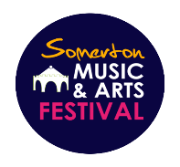

**The Somerton Music and Arts Festival**

**Art, Photography, Needlework and Wood Work Exhibition**

**26th May - 3rd June 2023**

**CONDITIONS OF ENTRY**

The Organising Committee is the committee appointed by the Somerton Music & Arts Festival to run the Art & Photography Exhibition. Any information you submit in regards to the entry of this exhibition will be retained in line with the SMAF Privacy Policy, a copy of which can be found online.

* Entry forms must be submitted by 12th May 2023 either online or by post clearly marked as "Art Exhibition Entry" to Jackie Thompson 3,Highfield Close, Somerton, TA11 6SZ
* No commercial work will be accepted
* All work must be original
* Only one piece submitted can be ‘NOT FOR SALE’
* It is the responsibility of the exhibitor to observe copyright laws as the Organising Committee will not accept liability for litigation / claims etc
* Exhibitors are responsible for the insurance cover of their work. Exhibitors should check with their insurer / broker to ensure that appropriate cover is in place. Whilst every care is taken, the Organising Committee cannot be held responsible for any loss or damage
* Commission of 15% will be charged by the Organising Committee on each sale
* The appropriate remittance must be paid at the time of entry (see details on entry form)
* Any entries received after the closing date of **Friday 12th May** will not be accepted
* Please bring your work to the Parish Rooms, on **Friday 26th May 2023**  between **4:00pm and 6.00pm**
* At 1:15pm Saturday 3rd June, the presentation of the certificates will be made to the winner of each category – Artwork, Photography, Needlework and Wood Work – based on votes cast by visitors. The hall will then close until 2pm
* Please collect your work between **2:00pm and 3:00pm** on **Saturday 3rd June**
* If you cannot collect your work in person, please provide a signed note authorising and naming the person representing you
* Please ensure that you have volunteered for at least one stewarding session during the exhibition.

**The Somerton Music and Arts Festival**

**Art, Photography, Needlework and Wood Work Exhibition**

**26th May - 3rd June 2023**

**PRESENTING YOUR WORK**

* For each individual item of needlework / framed art work / canvases / photography entered attach 2 labels. One label should be attached to a piece of string and fastened to the back of the work. The other, a sticky label, should be attached to the back of the Art work detailing the ARTIST’S NAME and EMAIL ADDRESS
* The Exhibition Committee reserves the right to refuse pieces submitted which have not been correctly labelled or have the means to display the work safely. By this we mean eyelets or picture hooks in place with string / wire / cord, for example:

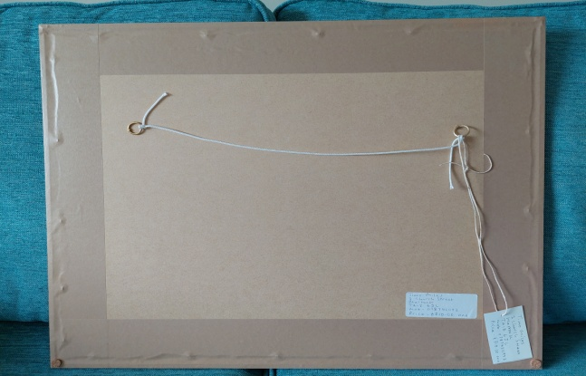

**FRAMED PHOTOGRAPHY / ARTWORK / CANVASES**

* You may enter **up to 4** framed pictures/canvases
* The **MAXIMUM SIZE** for framed work/canvas, including the frame, is **24”x 30”, (60cm x76cm)** the Committee has the right to refuse pieces of work which are larger than this
* Frames must be included in the price
* A charge of £3.00 will be made per item

**UNFRAMED ARTWORK AND PHOTOGRAPHY**

* You may enter **up to 5** unframed items
* Mounted pictures should be covered in cellophane to protect them and include on a label on the front the ARTISTS NAME, TITLE OF WORK and PRICE
* A charge of £1.00 per unframed item will be made

**The Somerton Music and Arts Festival**

**Art, Photography, Needlework and Wood Work Exhibition**

**26th May - 3rd June 2023**

**PRESEENTING YOUR WORK CONT.**

**WOOD WORK**

* You may enter up to 4 pieces of work
* **MAXIMUM SIZE 13" x 13" (35cm x 35cm)** the Committee has the right to refuse pieces of work which are larger than this
* A charge of £3.00 will be made per item

**NEEDLEWORK**

* You may enter up to 4 pieces of work
* A charge of £3.00 will be made per item
* Ideally, this should be an original creation but if produced from a kit, it must be labelled as such

**CARDS**

* You may enter **up to 50** cards
* All cards must be priced and come with a means to display
* Cards must be in a cellophane bag and be labelled with ARTIST’S NAME and PRICE